Analysis of Recursion Overhead in Quick Sort
Name: L. Ashraf Ali
Reg No: 192524192

Aim
Analyze the impact of recursion overhead in Quick Sort by measuring function call counts, recursion stack depth and execution time on large datasets.

Objective
Measure recursion cost, interpret its impact on performance, and justify optimization techniques such as tail recursion.

Algorithm
1. Generate a large random dataset.
2. Execute recursive Quick Sort.
3. Count recursive function calls.
4. Track maximum recursion depth.
5. Measure execution time.
6. Display and analyze the results.

Source Code
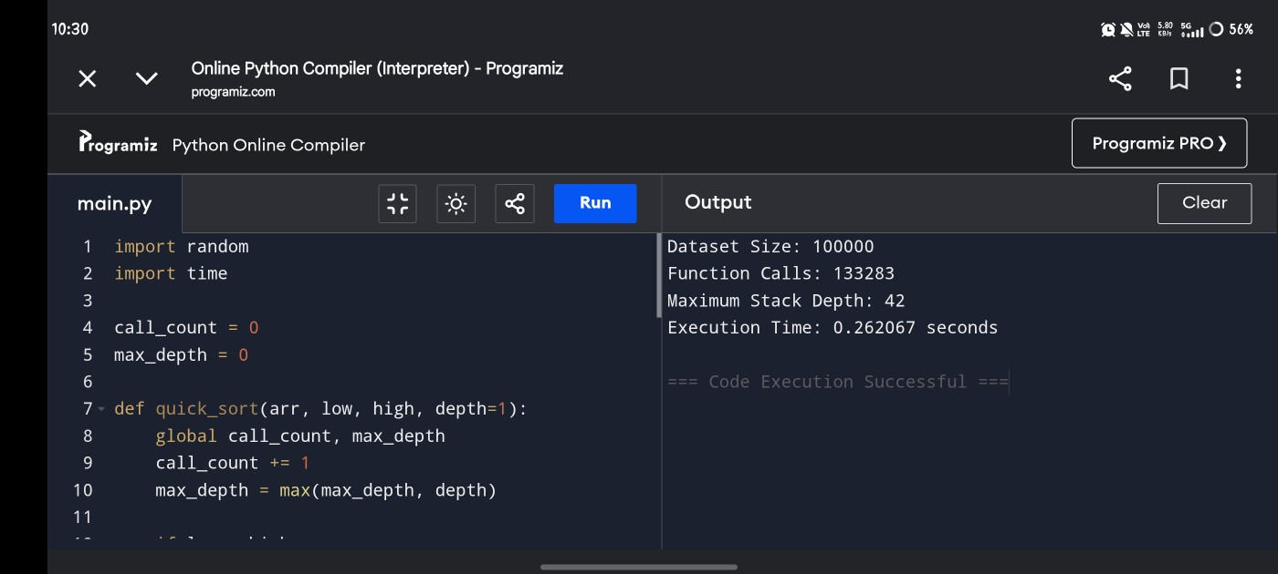

Output
Expected output includes Dataset Size, Function Calls, Maximum Stack Depth, and Execution Time.

Analysis
Recursive Quick Sort creates many function calls. Every recursive call adds stack overhead. Balanced partitions reduce maximum stack depth to approximately O(log n), while worst-case partitions increase depth to O(n), increasing execution time and memory usage.

Documentation
Function call count estimates recursion overhead. Stack depth represents memory consumed by recursive calls. Execution time includes partitioning work plus recursion management.

Optimization (Tail Recursion)
Tail recursion or converting one recursive branch into an iterative loop reduces stack usage. Randomized pivot selection and median-of-three pivot selection also reduce worst-case recursion depth.

Time Complexity
Best/Average: O(n log n)
Worst: O(n²)
Space (Recursion): O(log n) average, O(n) worst.

Conclusion
Recursion contributes significantly to execution cost through repeated function calls and stack allocation. Tail recursion optimization and improved pivot selection help reduce recursion overhead and improve efficiency.

